A stable relationship

Some nuclei are stable.
Other nuclei are unstable.
The strong nuclear force pulls protons and neutrons together.
The electrostatic force pushes protons apart.
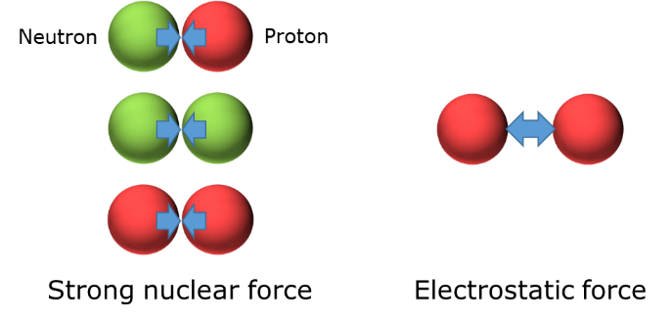

a. Which carbon nucleus do you think is more stable?
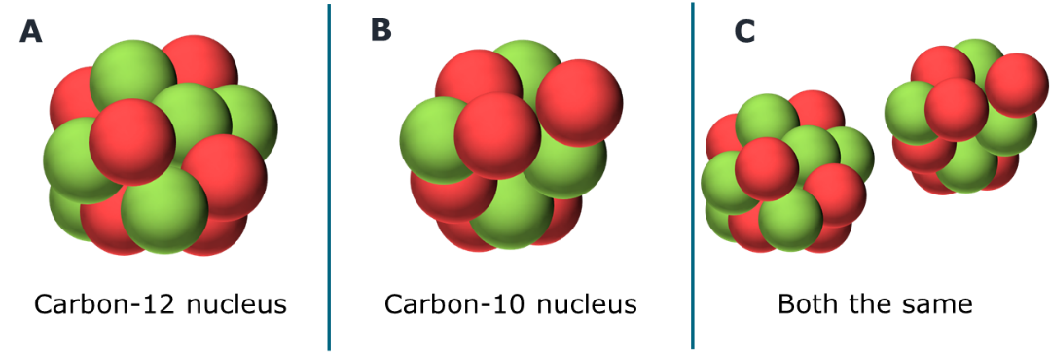
b. What is the best reason for your last answer?
Put a tick (✓) in the box next to the best answer.
A | Each have the same number of protons.
B | The protons are closer together.
C | The protons are further apart.
D | There are more neutrons.
The strong nuclear force gets its name because it is stronger than the electrostatic force.
It has a very, very short range and only acts between nucleons that are next to each other.
Physics > Big idea PMA: Matter > Topic PMA5: Nuclear physics > Key concept PMA5.1: Atomic nuclei
Diagnostic question
A stable relationship

Overview
Learning focus: | There is a fixed number of positively charged protons in the nucleus of each atom of an element, but the number of neutrons can vary to make isotopes that are either stable or unstable.
Observable learning outcome: | Explain why some nuclei are stable and others are not.
Question type: | Two-tier multiple choice
Key words: | Stable, unstable, nucleus, strong nuclear force, electrostatic force, proton, neutron, nucleon

B | BRIDGING  This diagnostic question probes understanding of ideas that are usually taught at age 16-19, to build a bridge to later stages of learning.

What does the research say?
The level of awareness is low amongst students, age 13-18, that an electrostatic force attracts electrons to a nucleus and causes electrons around a nucleus (or protons within a nucleus) to repel each other (Harrison and Treagust, 1996; Tabor, 2013).
To develop a deeper understanding of the structure of nuclei, Brock, Manning and Walsh (2021) suggest starting by reinforcing understanding of the structure and scale of an atom by modelling Rutherford’s scattering experiment. Their next step is to introduce the proton and neutron, and to use nomenclature to give students opportunity to explore the numbers of protons, neutrons and electrons in different atoms. This introduces students to ideas about isotopes and about what makes some nuclei stable and others unstable (radioactive).
This question checks students’ understanding about why different numbers of protons and neutrons make a nucleus more or less stable.
Ways to use this question
Students should complete the questions individually. This could be a pencil and paper exercise, or you could use an electronic ‘voting system’ or mini white boards and the PowerPoint presentation. The follow-on question will give you insights into how they are thinking and highlight specific misconceptions that some may hold.
If there is a range of answers, you may choose to respond through structured class discussion. Ask one student to explain why they gave the answer they did; ask another student to explain why they agree with them; ask another to explain why they disagree, and so on. This sort of discussion gives students the opportunity to explore their thinking and for you to really understand their learning needs.
Differentiation
You may choose to read the questions to the class, so that everyone can focus on the science. In some situations, it may be more appropriate for a teaching assistant to read for one or two students.
Expected answers
a. A
b. C
How to respond - what next?
The protons in each nucleus are held together by the strong nuclear force. They are attracted to adjoining nucleons with a force that is largely dependent on the number of other nucleons they are next to, which is approximately the same in each nucleus.
Protons are pushed apart by the electrostatic force that acts over large distances. With more neutrons in nucleus A, the protons are further apart than that in nucleus B, and the electrostatic repulsion between them is less.
Most students understand that electrostatic force between charged particles decreases with distance and that protons repel more strongly if they are closer. However, some students may not understand how having fewer neutrons in a nucleus can result in protons being closer together. These students are likely to choose options C, A, for parts a and b respectively.
Often students misunderstand the effect of the strong nuclear force in a nucleus. Some students are likely to think that increasing the number of neutrons increases the strong nuclear force across the whole nucleus. These students are likely to choose options A, D.
If students have misunderstandings about explaining why some nuclei are stable and others are not, it can help to model the forces using coins or coloured discs:
- the heads of coins can represent protons and tails can represent neutrons
- the numbers heads and tails for the two different nuclei can be arranged (in 2D) to be as close together as possible
- the strength of the strong nuclear force on a particular proton can be ‘measured’ by counting the number of adjacent nucleons it is in ‘contact’ with
- by observation this can be seen to be about the same for each nucleus
- the strength of the electrostatic force is bigger if protons are closer together
- and by observation it can be seen that with fewer neutrons, the same number of protons are closer together.
Careful questioning should elicit the understanding that:
- adding extra protons increases the force pushing the protons apart
- and that increasing the number of neutrons moves them further apart to reduce the electrostatic force, which makes a more stable nucleus.
The following BEST ‘response activity’ could be used in follow-up to this diagnostic question:
- Response activity: Pushing apart

Acknowledgments
Developed by Peter Fairhurst (UYSEG).
Images: Peter Fairhurst (UYSEG).
References
Brock, R., Manning, A. and Walsh, K. (2021). Atomic physics. In de Winter, J. & Hardman, M. (eds.) Teaching Secondary Physics. 3rd ed. London: Hodder Education.
Harrison, A. G. and Treagust, D. F. (1996). Secondary students' mental models of atoms and moelcules: Implications for teaching chemistry. Science Education, 80(5), 509-534.
Tabor, K. S. (2013). Upper secondary students' understanding of the basic physical interactions in analogous atomic and solar system models. Research in Science Education, 43, 1377-1406.

